



2025

PROJECT DOCUMENTATION  
SecureCloud Scheduler

Cloud Computing  
  
Karan Dubey

Intern ID: IP-6581

|  |  |  |  |
| --- | --- | --- | --- |
| **Created By:** | Karan Dubey | **Approved By:** | Harshada Topale |
| **Created On:** | 22-02-2025 | **Approved On:** | 24-04-2025 |

**📑 Table of Contents**

|  |  |  |
| --- | --- | --- |
| **S.No** | **Section** | **Page No.** |
| 1 | Introduction | 1 |
| 2 | Step-by-Step Deployment Guide |  |
| 2.1 | Step 1: Create a Linux VM on Azure | 1 |
| 2.2 | Step 2: Connect to VM and Clone Docker Repo | 2 |
| 2.3 | Step 3: Setup Environment Variables (.env) | 3 |
| 2.4 | Step 4: Docker Compose Setup | 4 |
| 2.5 | Step 5: Start the Cal.com App | 5 |
| 3 | Networking & Domain Setup |  |
| 3.1 | Step 6: Configure DNS (Azure DNS Zone) | 6 |
| 3.2 | Step 7: Configure HTTPS with Caddy | 7 |
| 4 | Cal.com Application Features | 8 |
| 5 | Scaling & Monitoring |  |
| 5.1 | Step 8: Set up Azure VM Scale Set | 9 |
| 5.2 | Step 9: Creating Alerts for Failures | 10 |
| 5.3 | Step 10: Monitoring (Logs, Cost Alerts) | 10 |
| 6 | Project Submission |  |
| 6.1 | Step 11: Push Project to GitHub | 11 |
| 6.2 | Step 12: Create ZIP File for Submission | 12 |
| 6.3 | Step 13: Record and Submit Demo Video | 13 |
| 7 | References & Useful Links | 13 |

**Cal.com on Azure - Deployment Guide**

**Azure Resource Architecture:**

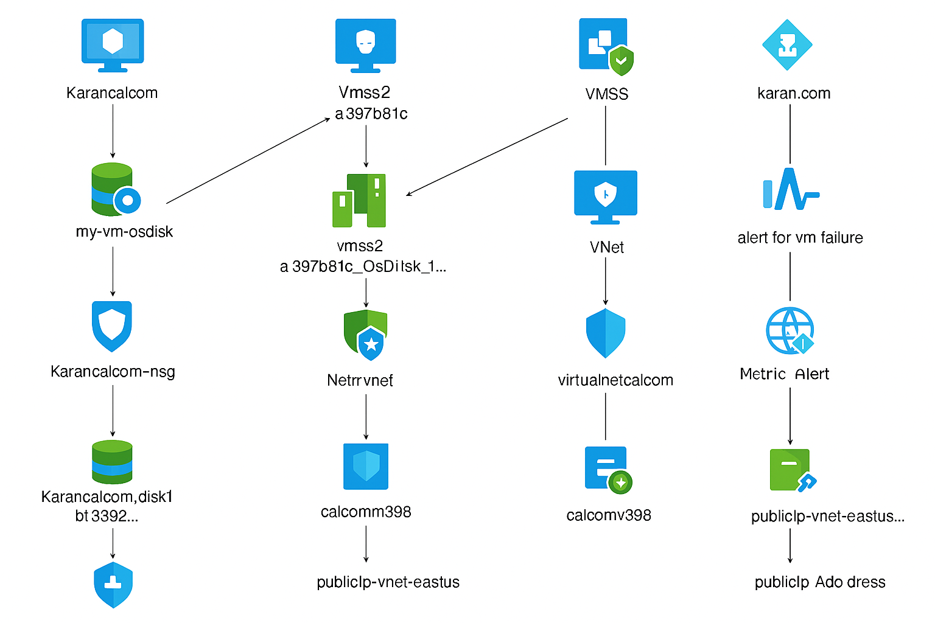

This document explains how I deployed Cal.com using Docker Compose on an Azure Linux VM with HTTPS support via Caddy.

**Step 1: Create a Linux VM on Azure**

1. Go to Azure Portal

- Navigate to [portal.azure.com](https://portal.azure.com)

- Search for Virtual Machines and click Create

2. Configure the VM

- Resource group: calcom-project2

- VM name: Karancalcom

- Region: Choose your preferred region

- Image: Ubuntu 22.04 LTS

- Size: Standard B1s or B1ms (for demo)

- Authentication type: Password or SSH

- Inbound Ports: Allow SSH (22), HTTP (80), and HTTPS (443)

3. Review + Create

- Click Review + Create

- Wait for deployment to complete

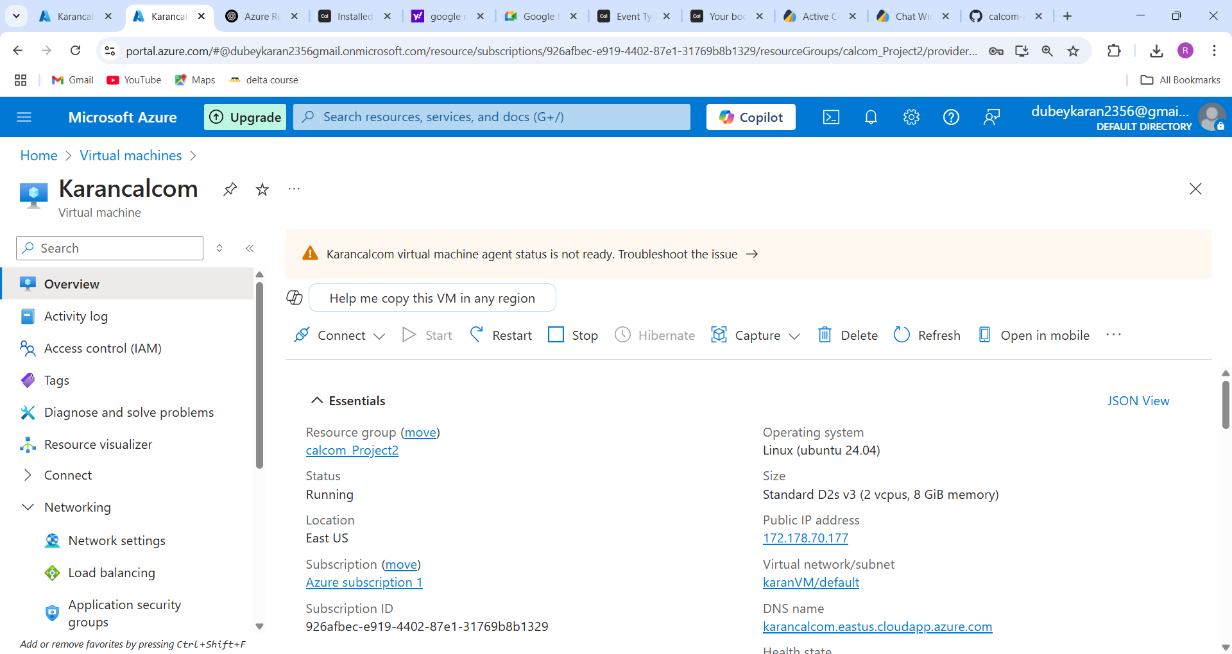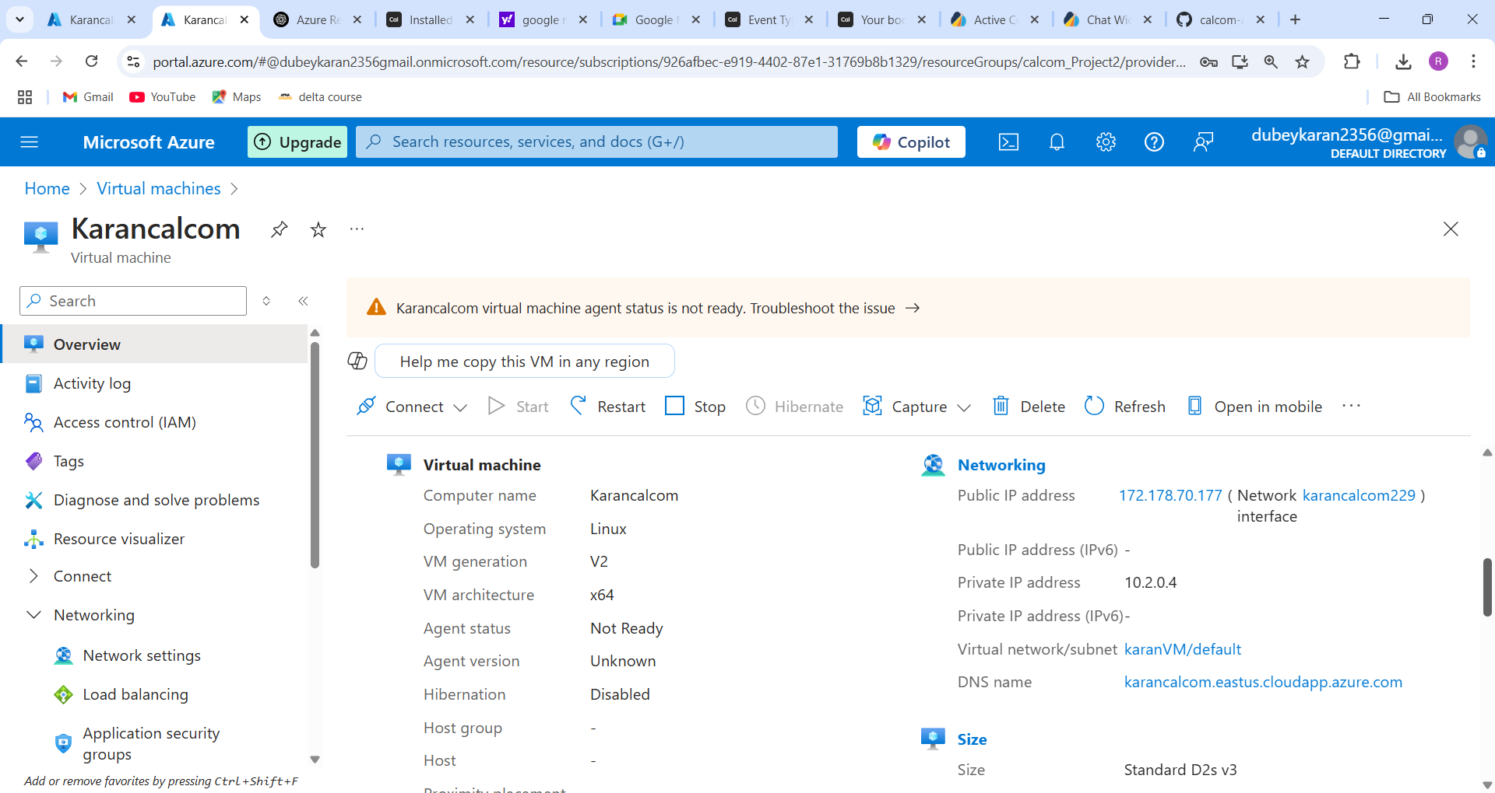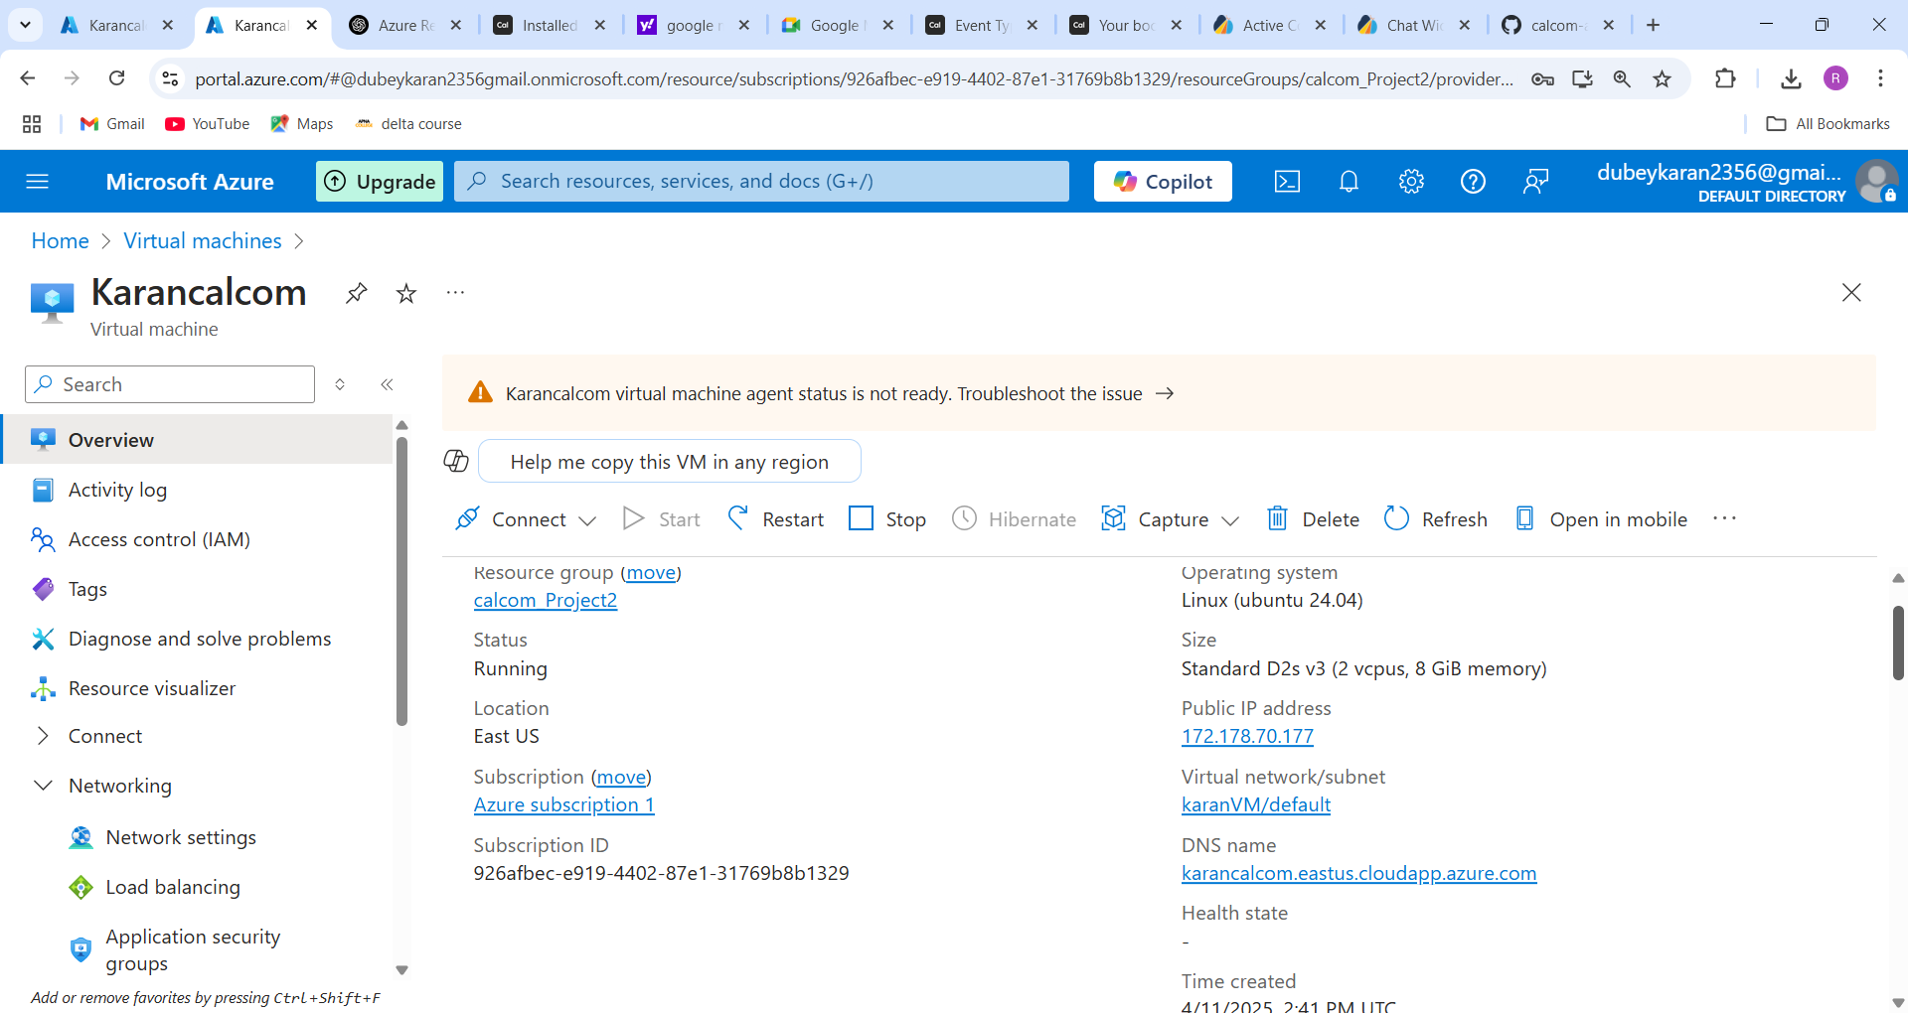

**Step 2: Connect to the VM and clone the Docker repo**

1. SSH into the VM

Command:

ssh azureuser@<your-vm-ip>

sudo apt update && sudo apt install git -y

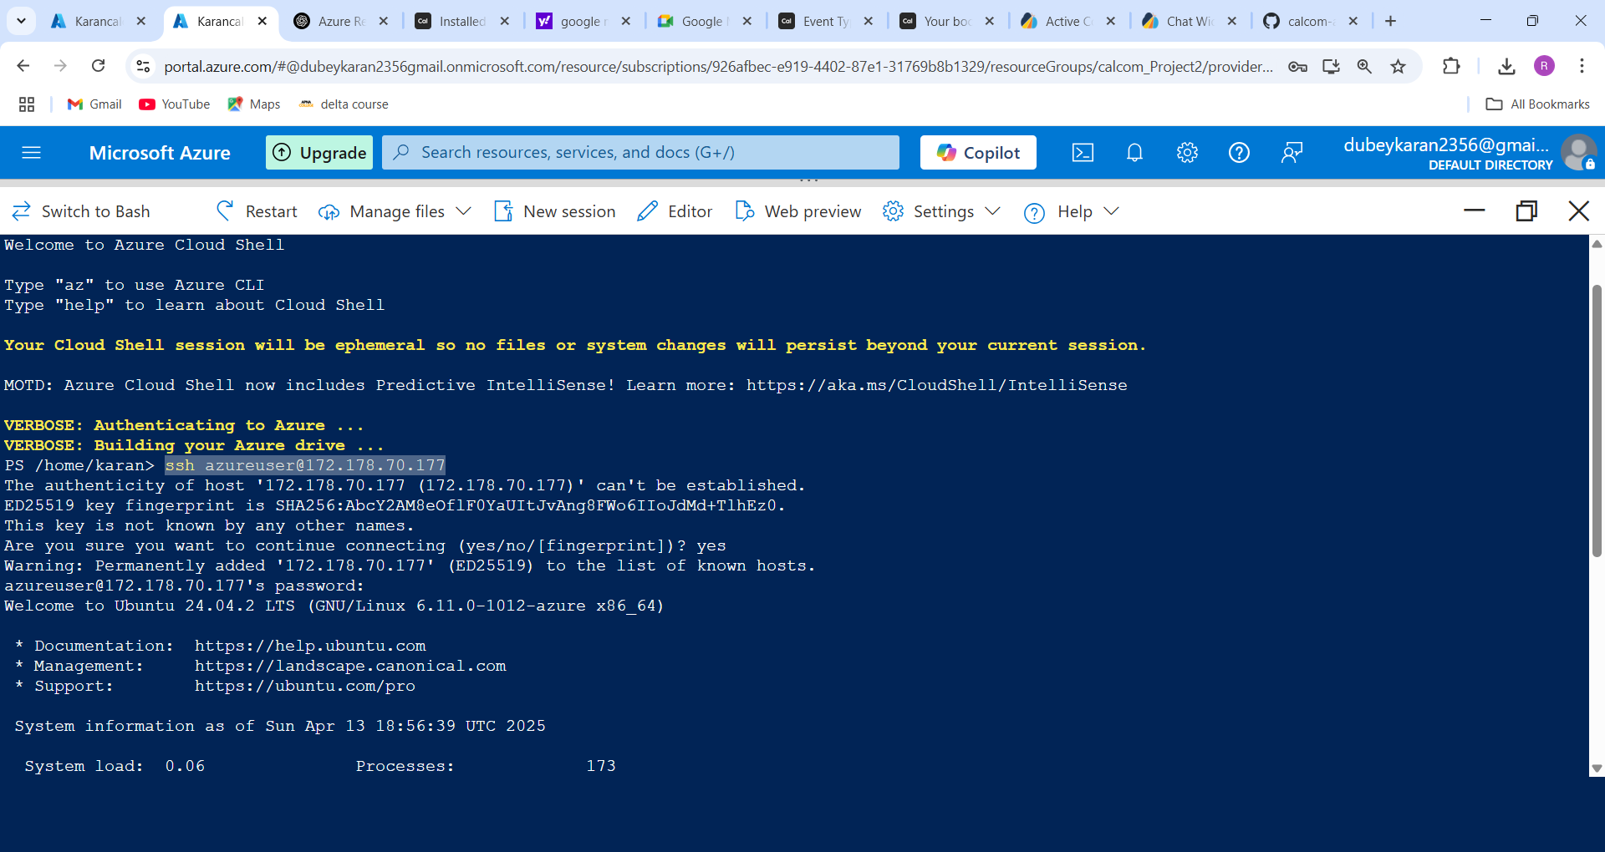

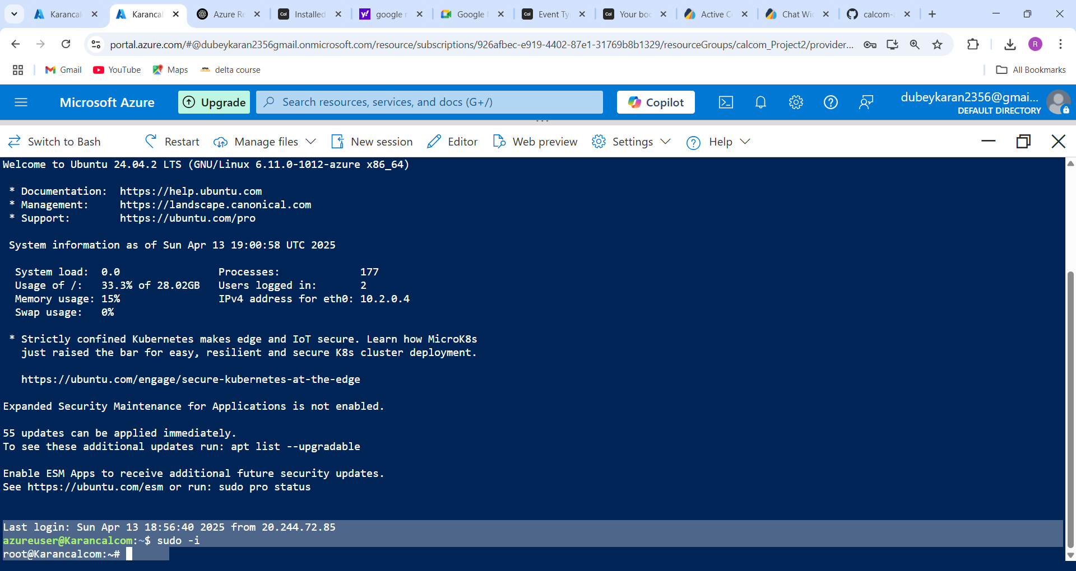

**Clone open source project from GitHub**

**Create a folder name Docker using mkdir within docker folder create gitclone using command**

git clone <https://github.com/calcom/docker.git>

after that you will see multiple folder it also has one docker folder if you don’t want to confuse with the folder docker that we are create you can change folder name with another meaning full name

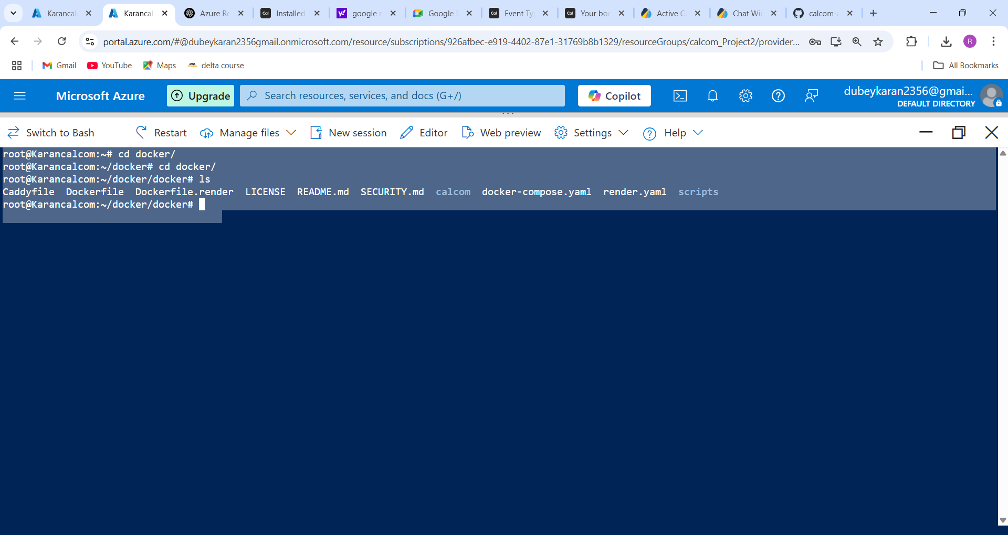

**Step 3: Setup Environment Variables (.env file)**

Before running Docker, we need to configure environment variables required by Cal.com.

1. now we have to configure env file so we need to copy .env.example file to .env file

**cp .env.example .env**

Now we have to edit .env file using command

**vi .env**

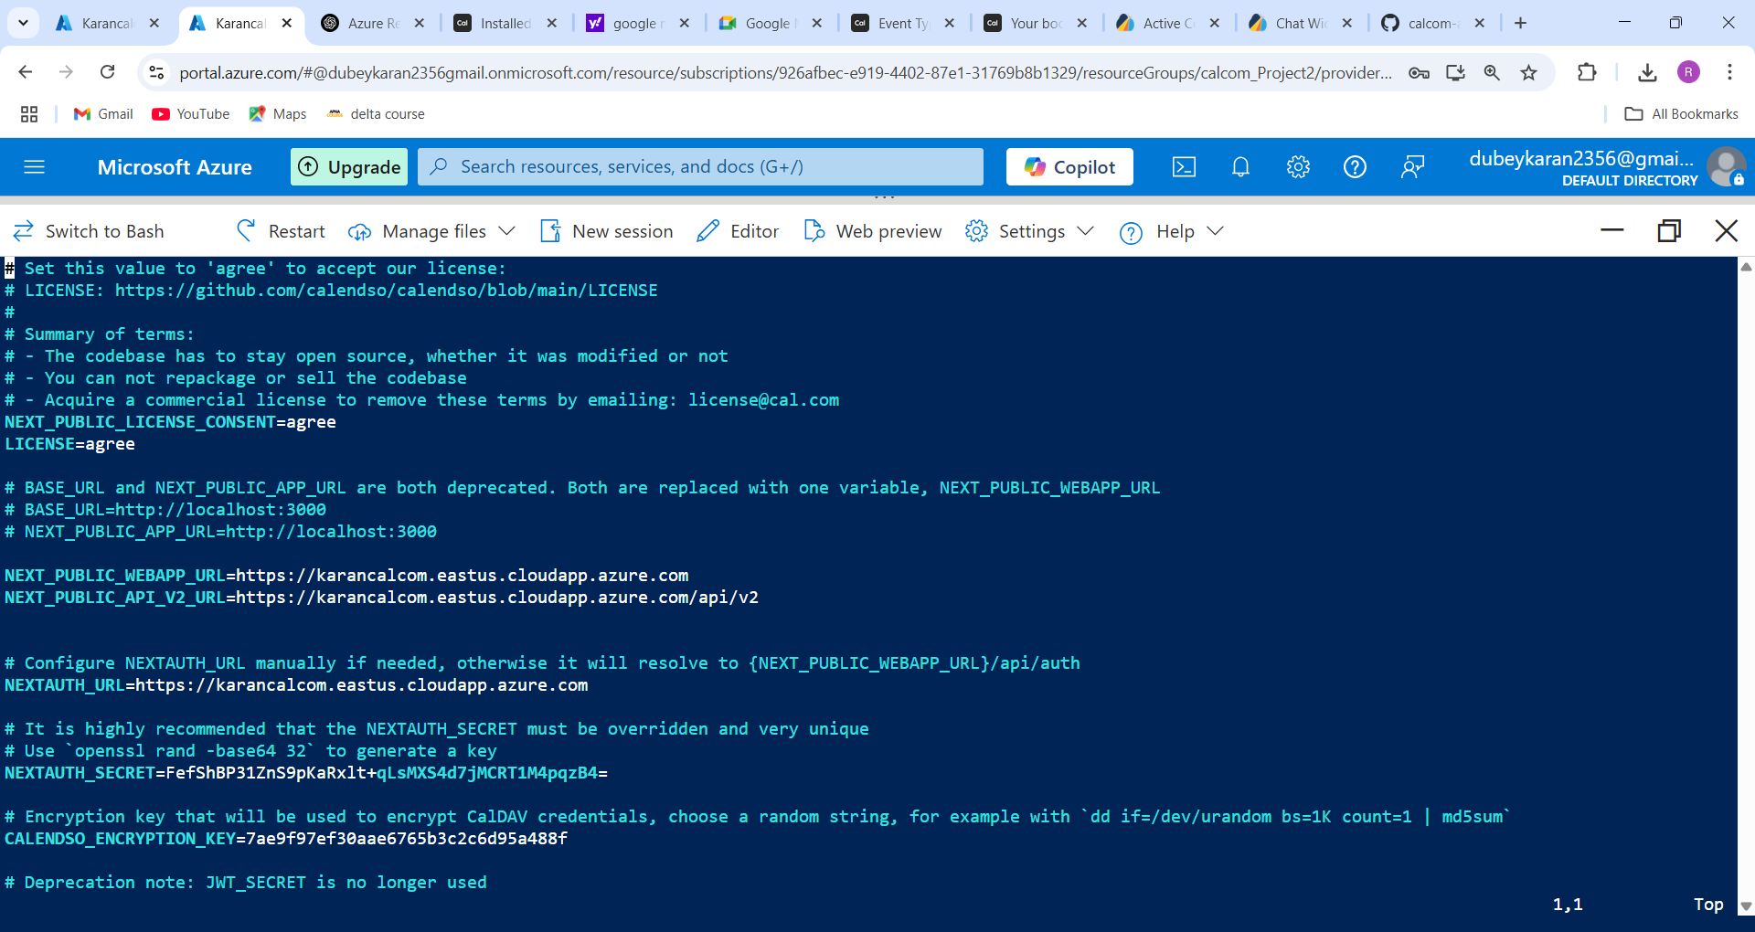

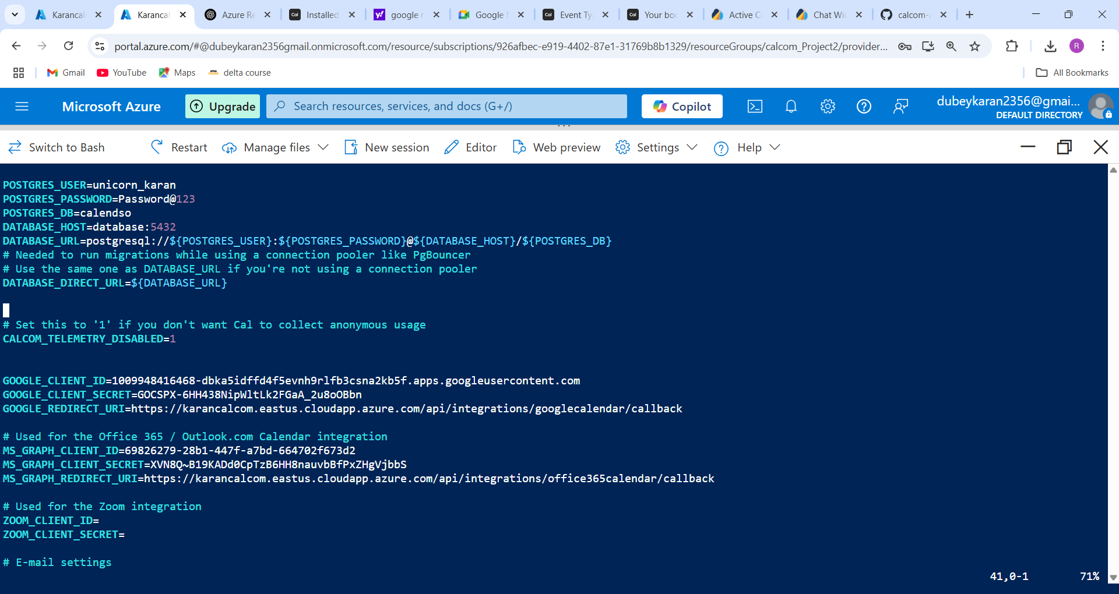

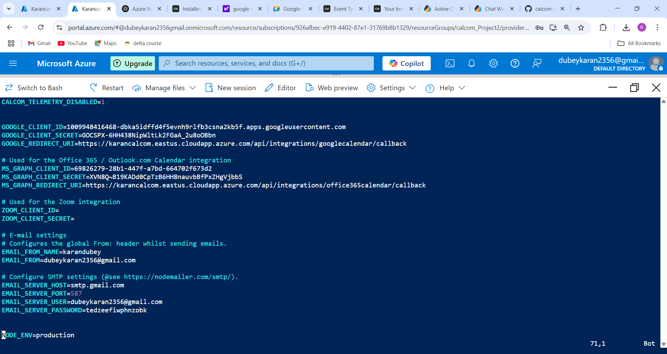

**Tip: You can generate a secure random key using:**

openssl rand -hex 32

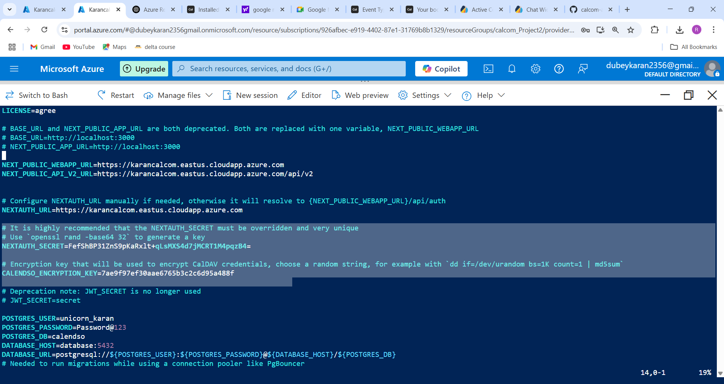

**Step 4: Docker Compose Setup**

Cal.com uses multiple containers managed with Docker Compose.

**1. Make sure Docker and Docker Compose are installed**

sudo apt install docker.io docker-compose -y

sudo systemctl enable docker

sudo systemctl start docker

**2. Verify Docker installation**

docker --version

docker-compose –version

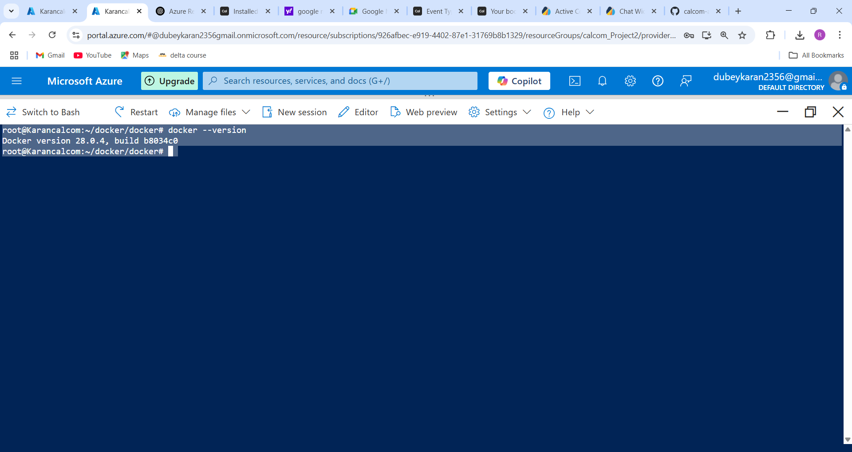

We also have to do changes in yaml file **docker-compose.yaml** , we need to configure yaml file .

Yaml file configuration below:

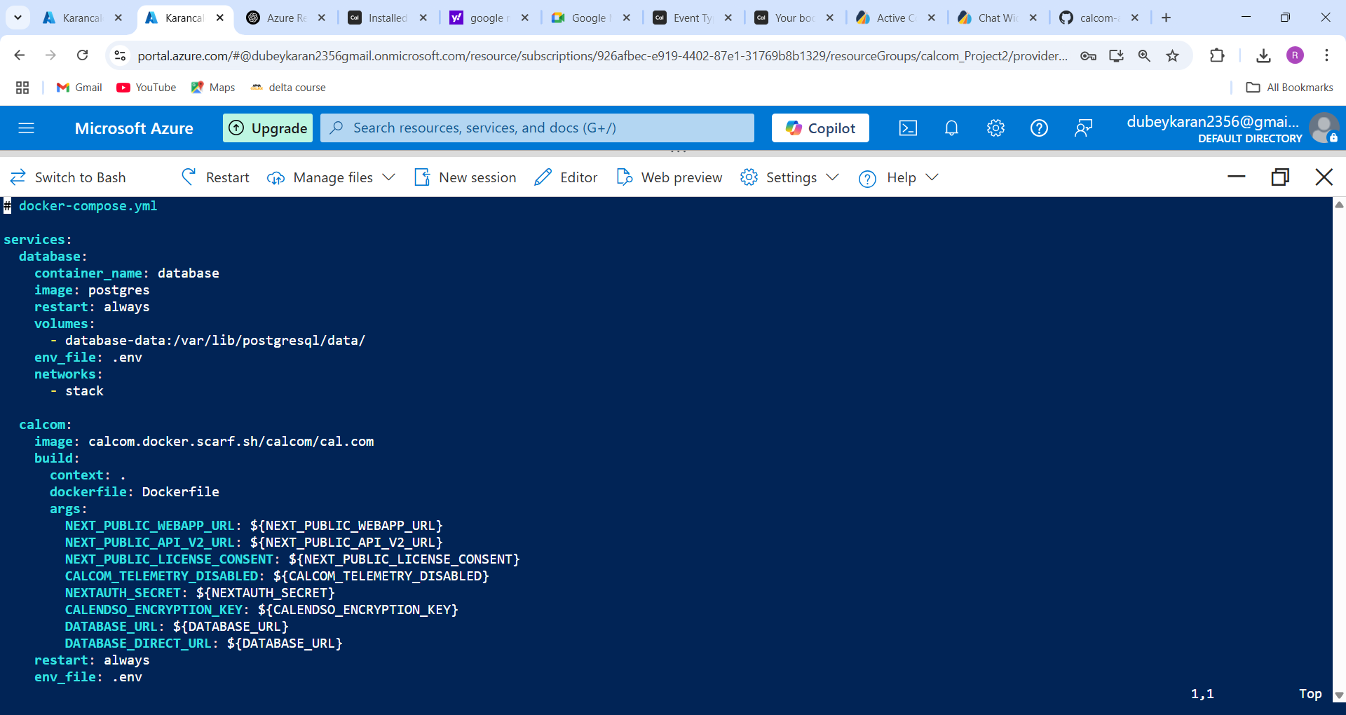

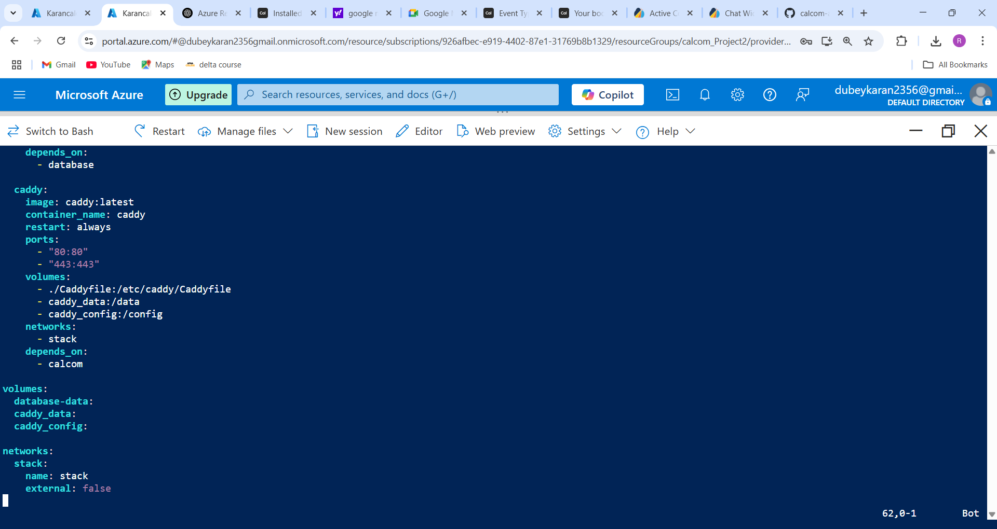

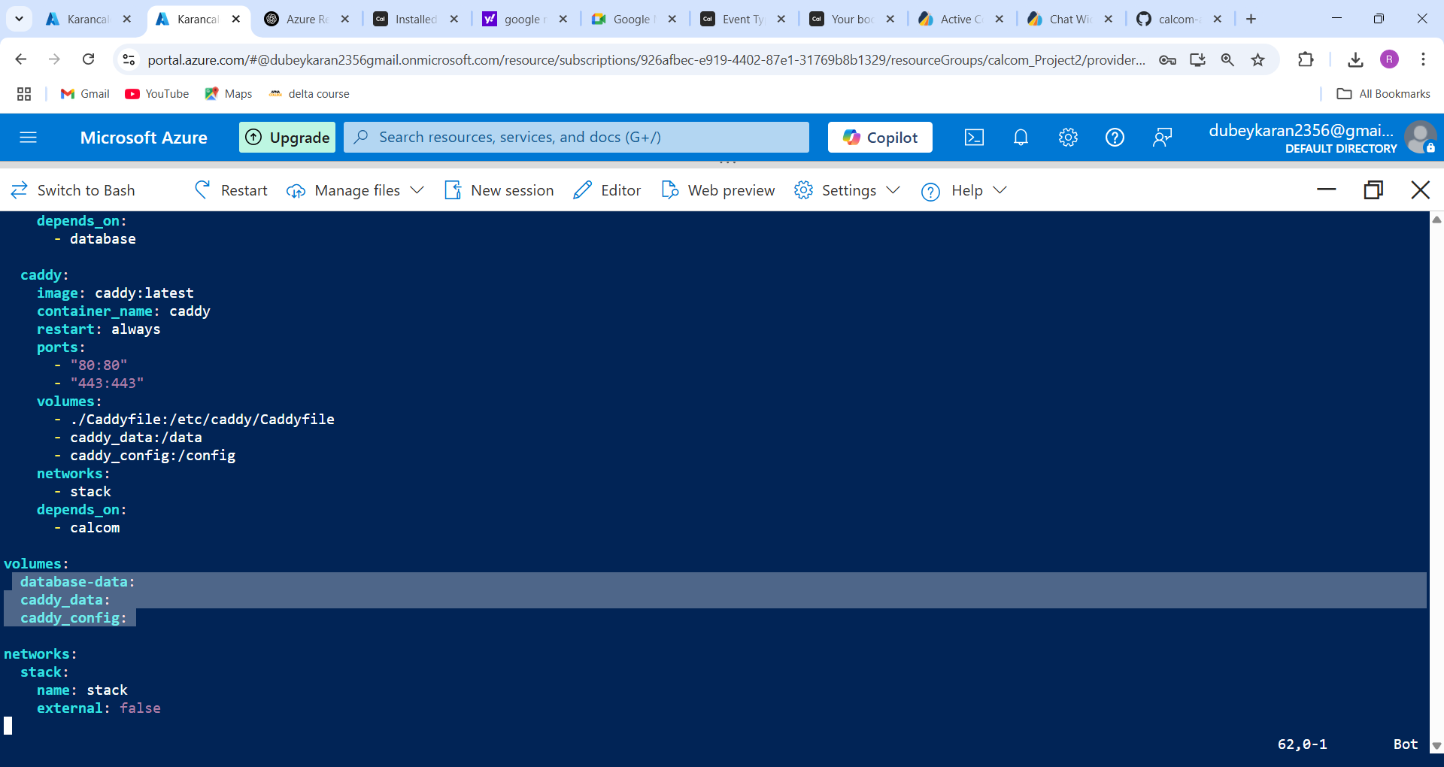

**✅ Step 5: Start the Cal.com app**

**1. Run Docker Compose**

From inside the docker folder:

docker-compose up -d

* This command will pull all required images and start the containers in detached mode.

**2. Check container status**

Command - docker ps

* calcom-web
* calcom-db (PostgreSQL)
* calcom-caddy (for HTTPS)

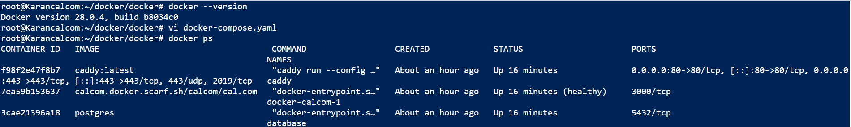

**✅ Step 6: Configure DNS (Azure)**

If you're using Azure-provided domains (like *.cloudapp.azure.com), follow these steps: I didn’t buy any domain for hosting I used azure DNS zone

**1. Go to Azure Portal → DNS Zones**

* Create a new **DNS Zone** if you haven't already
* Example: calcom.com or calcom.local

**2. Add a new A record:**

* **Name**: @ or your subdomain
* **Type**: A
* **TTL**: 300
* **IP address**: Your VM’s public IP

⚠️ It might take a few minutes for the DNS to propagate.

**📸 Screenshot:**

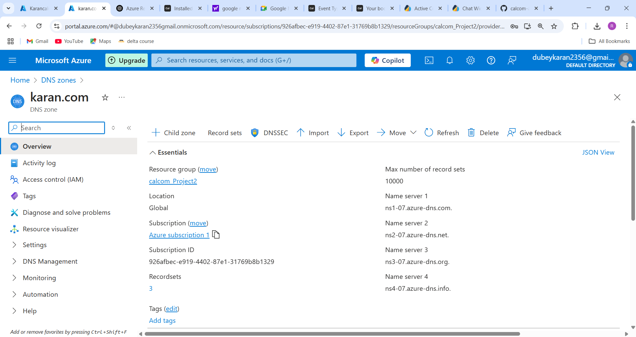

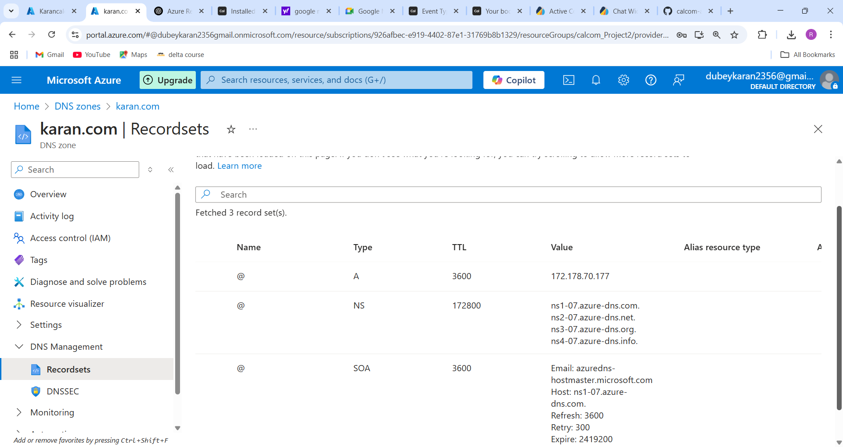

Now you can access your app at:

But first you have to configure DNS from your virtual machine

Go to virtual machine you see DNS it is not configured you have to configure it then you link is working

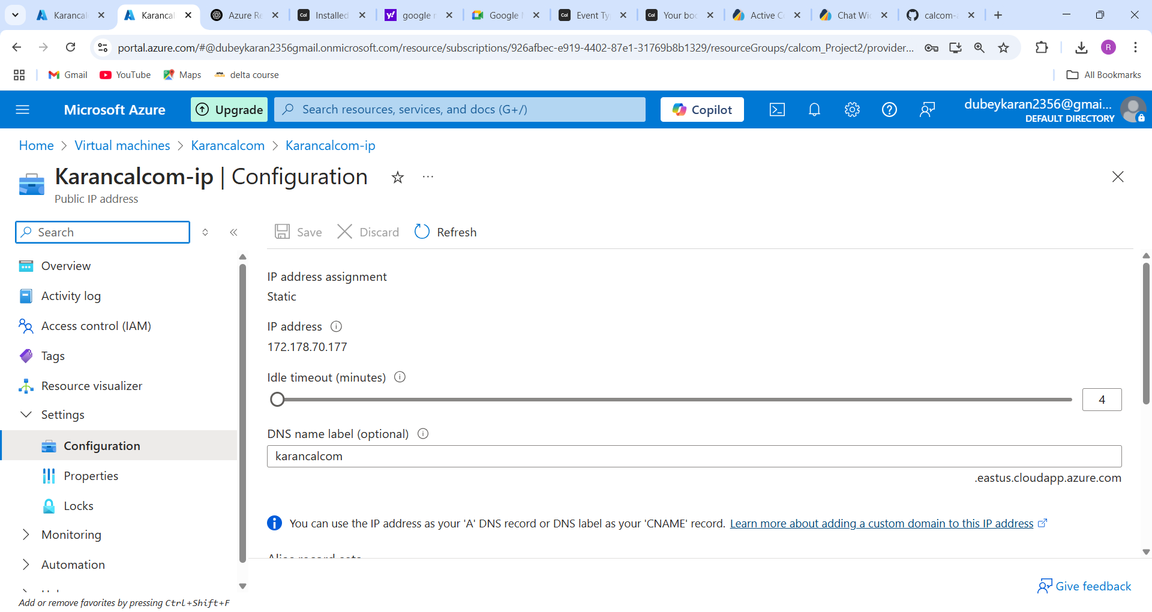

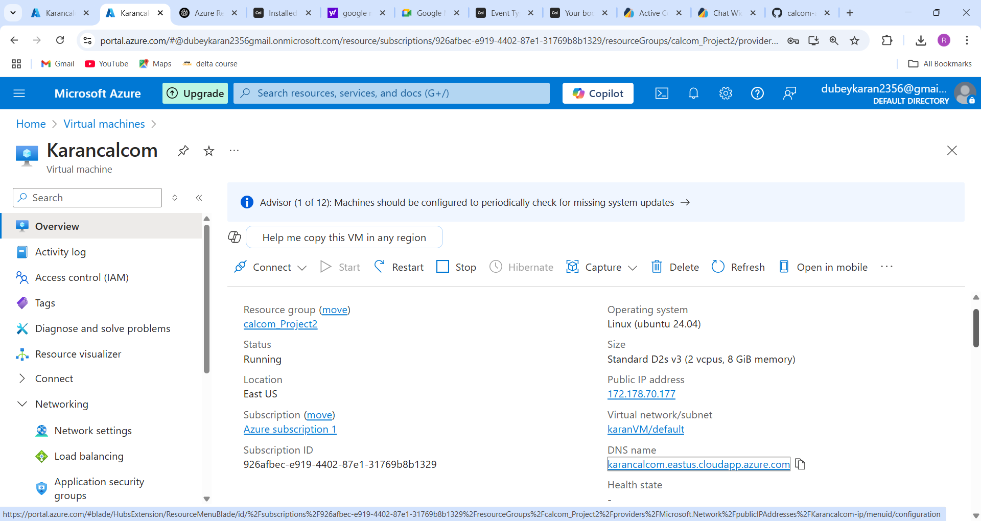

Now you are able to access your website

<https://calcom.centralindia.cloudapp.azure.com> but it will not secure you have to make it secure using SSL and TSL certificate, here I have user reverse proxy caddy to secure website without buying SSL and TSL certificate, below are the steps:

**Step 7: Configure HTTPS with Caddy**

Caddy is used as a reverse proxy to serve Cal.com over HTTPS.

1. Create a Caddyfile

Inside your docker folder, create a Caddyfile

nano Caddyfile

**2. Add the following content inside Caddyfile:**

karancalcom.eastus.cloudapp.azure.com {

reverse_proxy calcom:3000

}

Replace calcom.centralindia.cloudapp.azure.com with your actual domain. web:3000 refers to the Cal.com container name and port from docker-compose.yaml.

**3. Ensure port 443 is open**

Make sure your Azure VM allows inbound access on ports **80** and **443** in **Networking > Inbound Rules**.

**📸 Screenshot:**

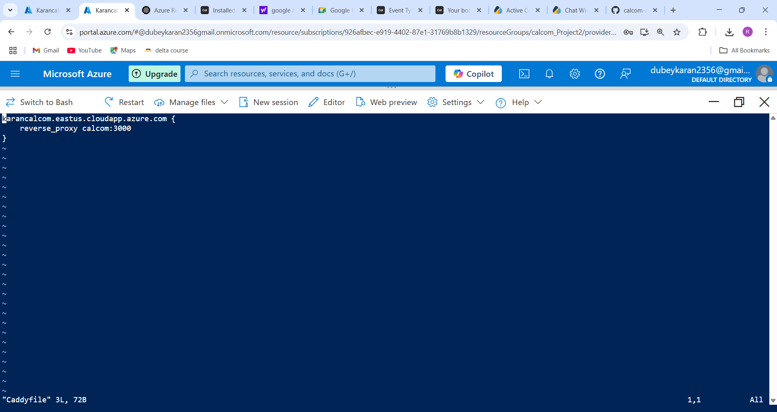

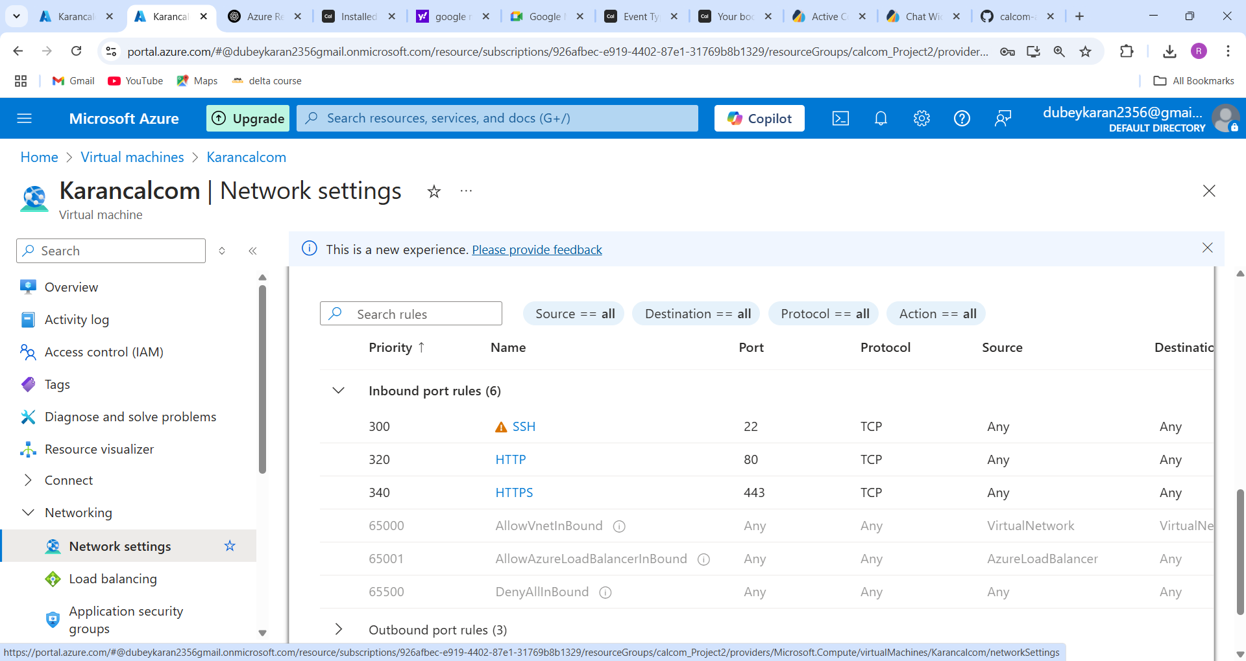

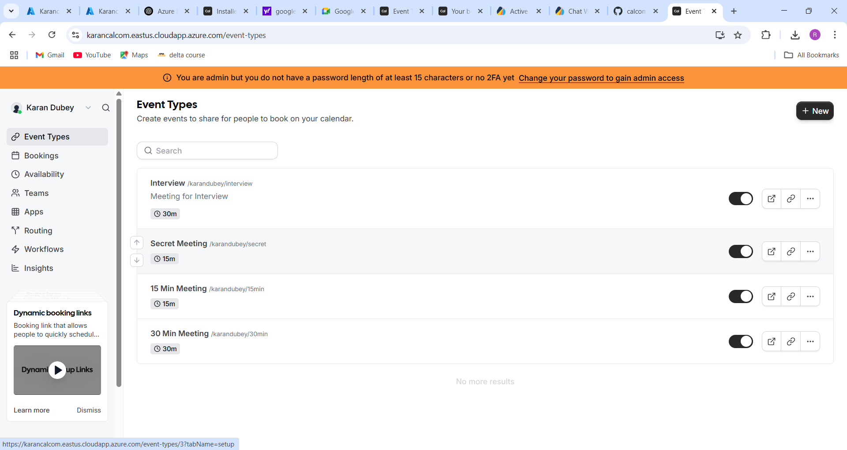

Bookings:

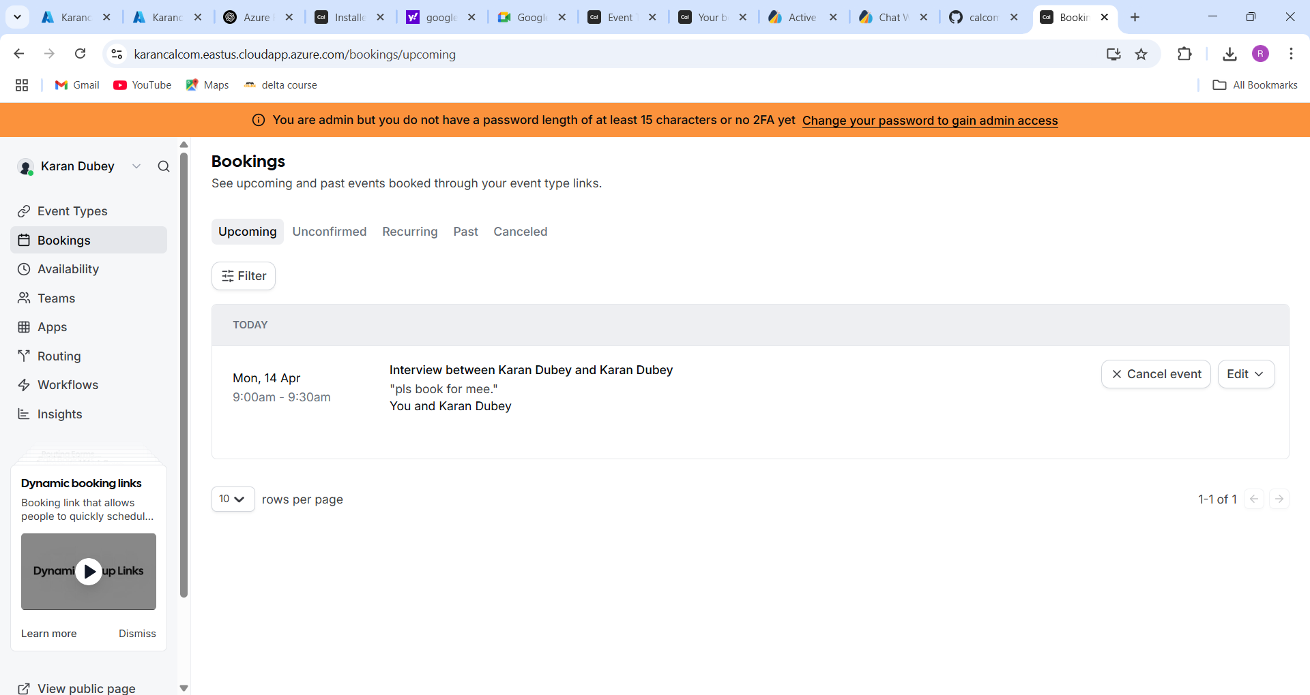

App installed:

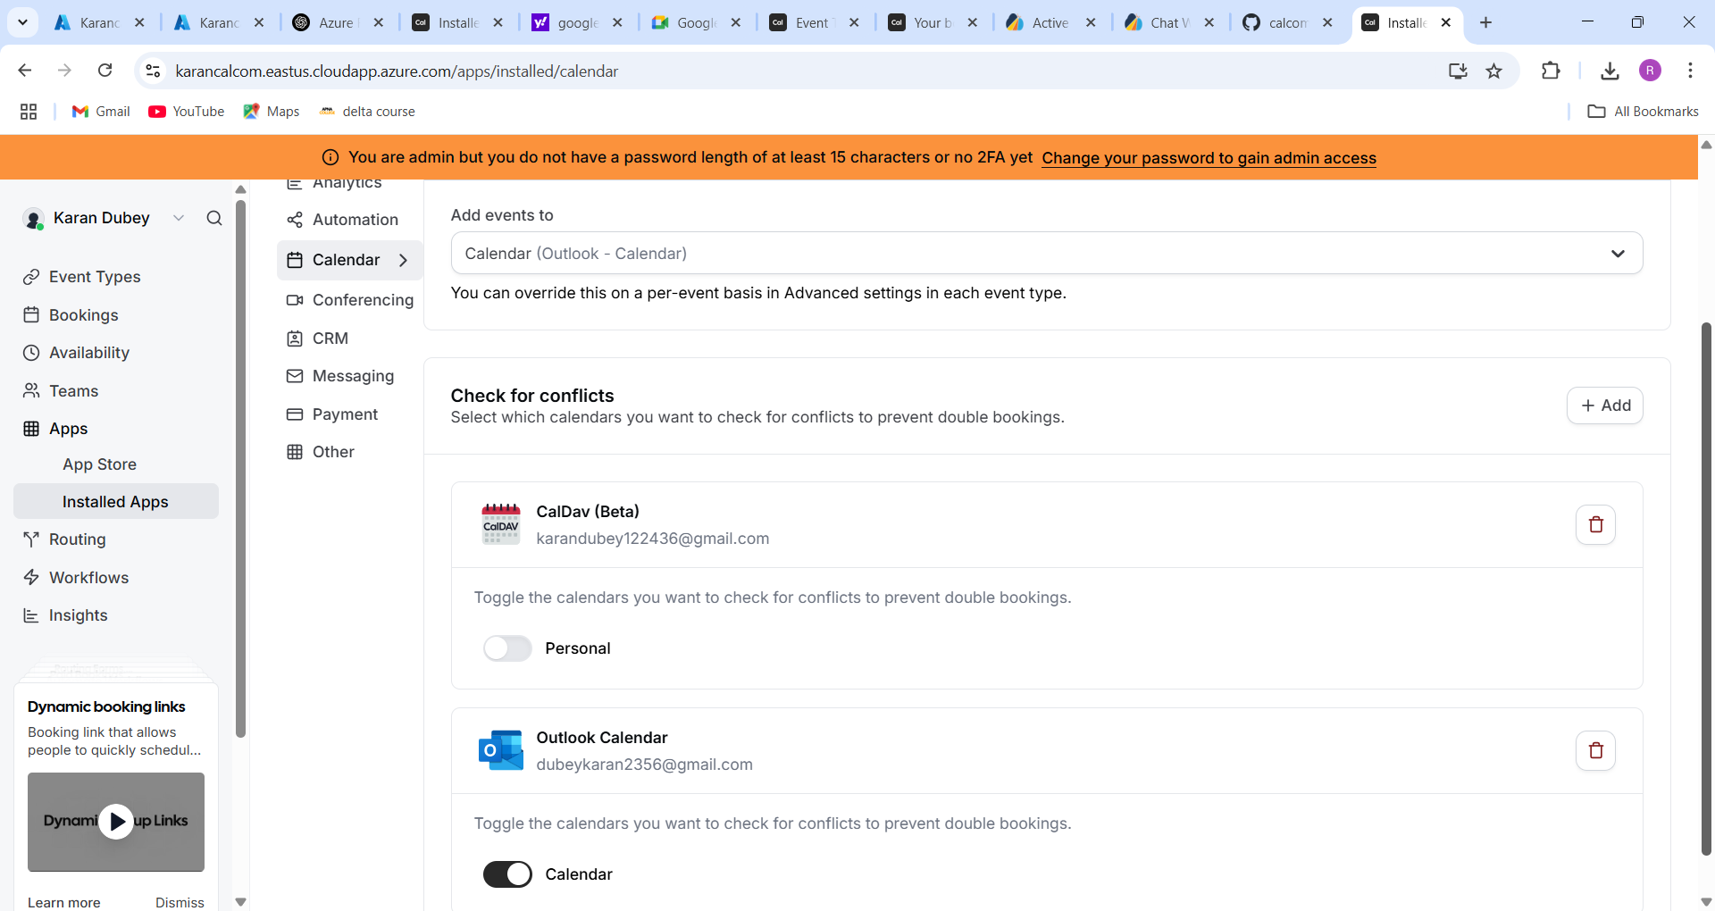

Public View Page:

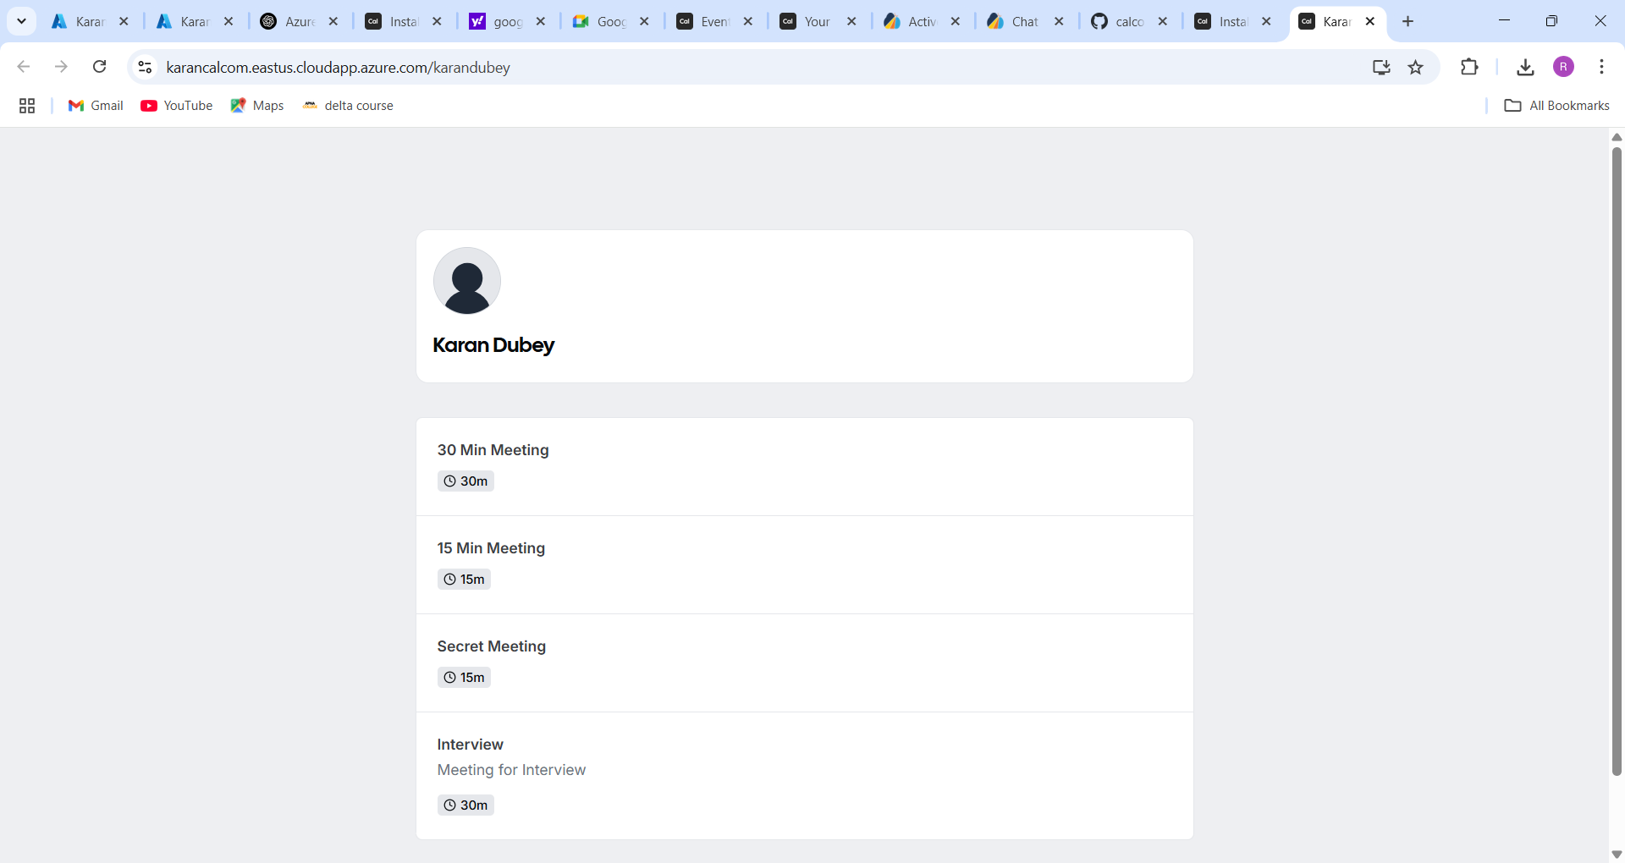

Add new events:

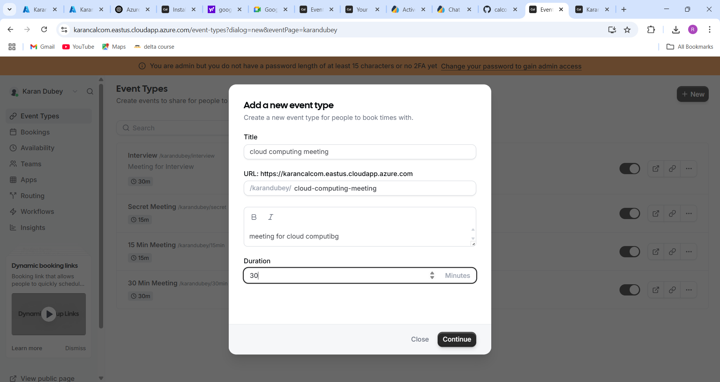

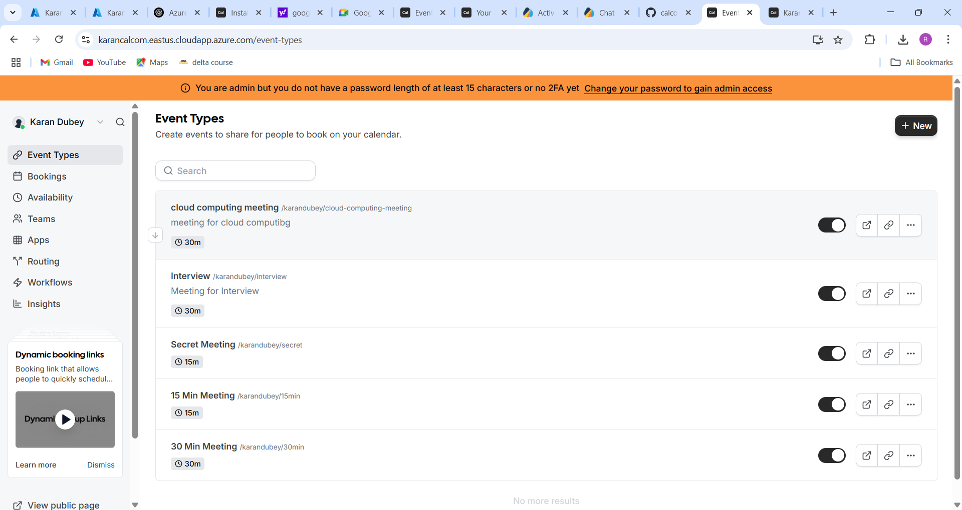

Booking:

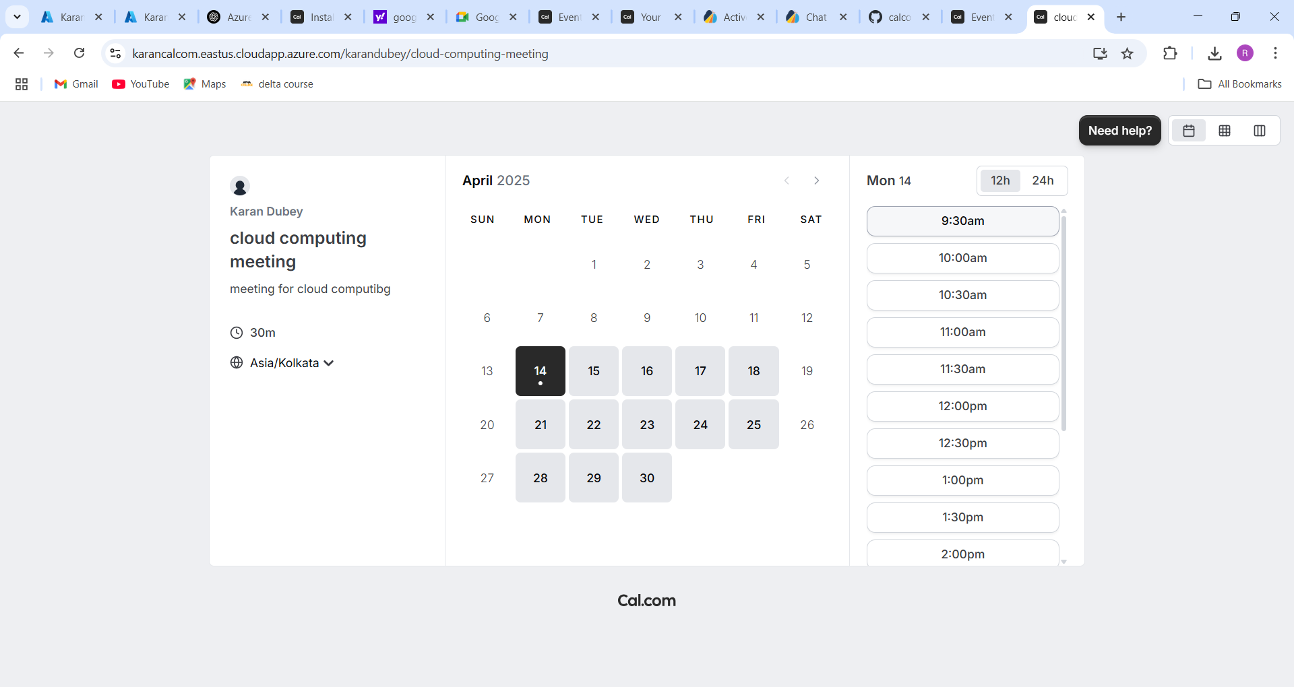

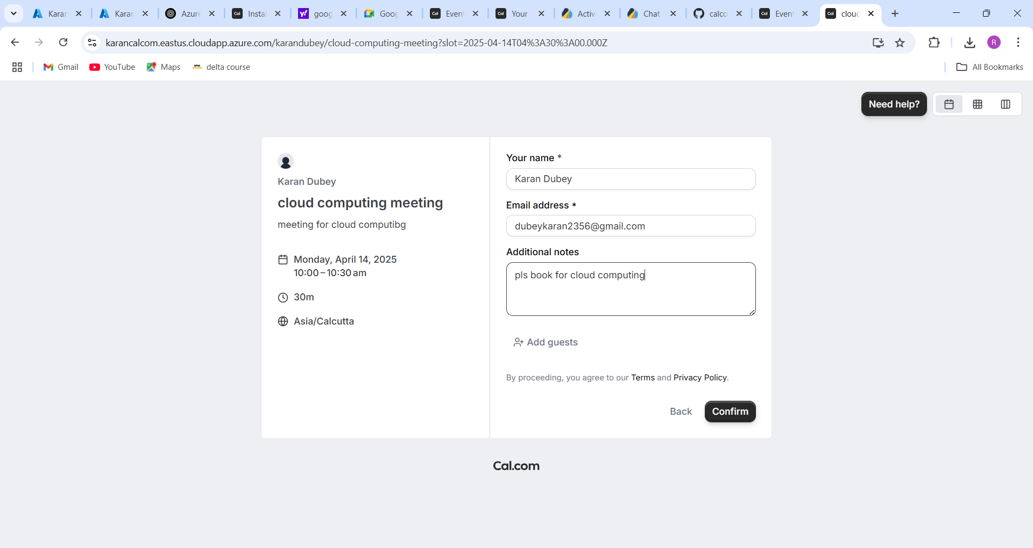

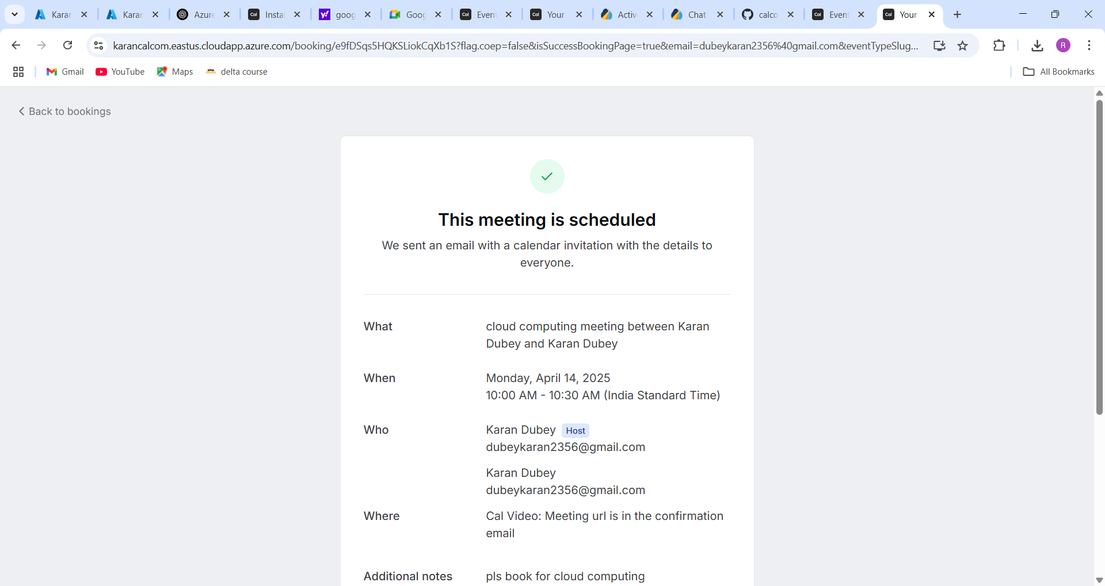

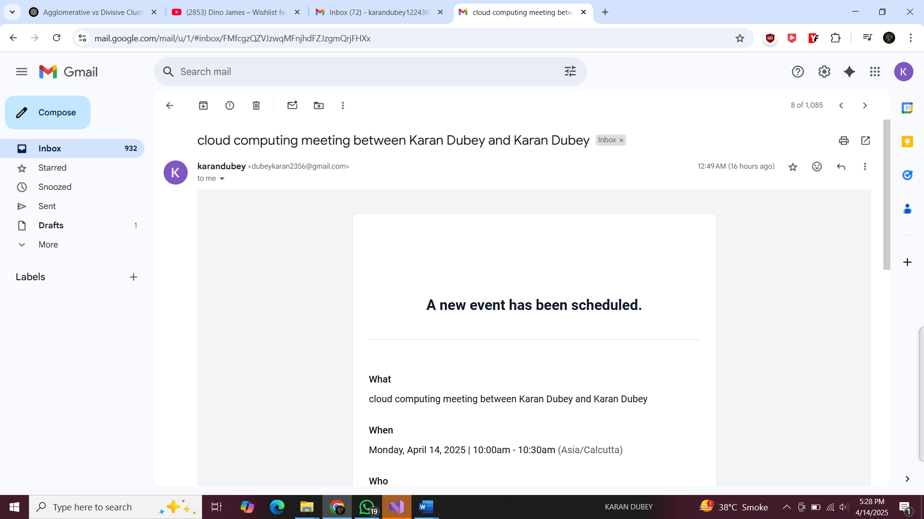

Now I will get confirmation mail :

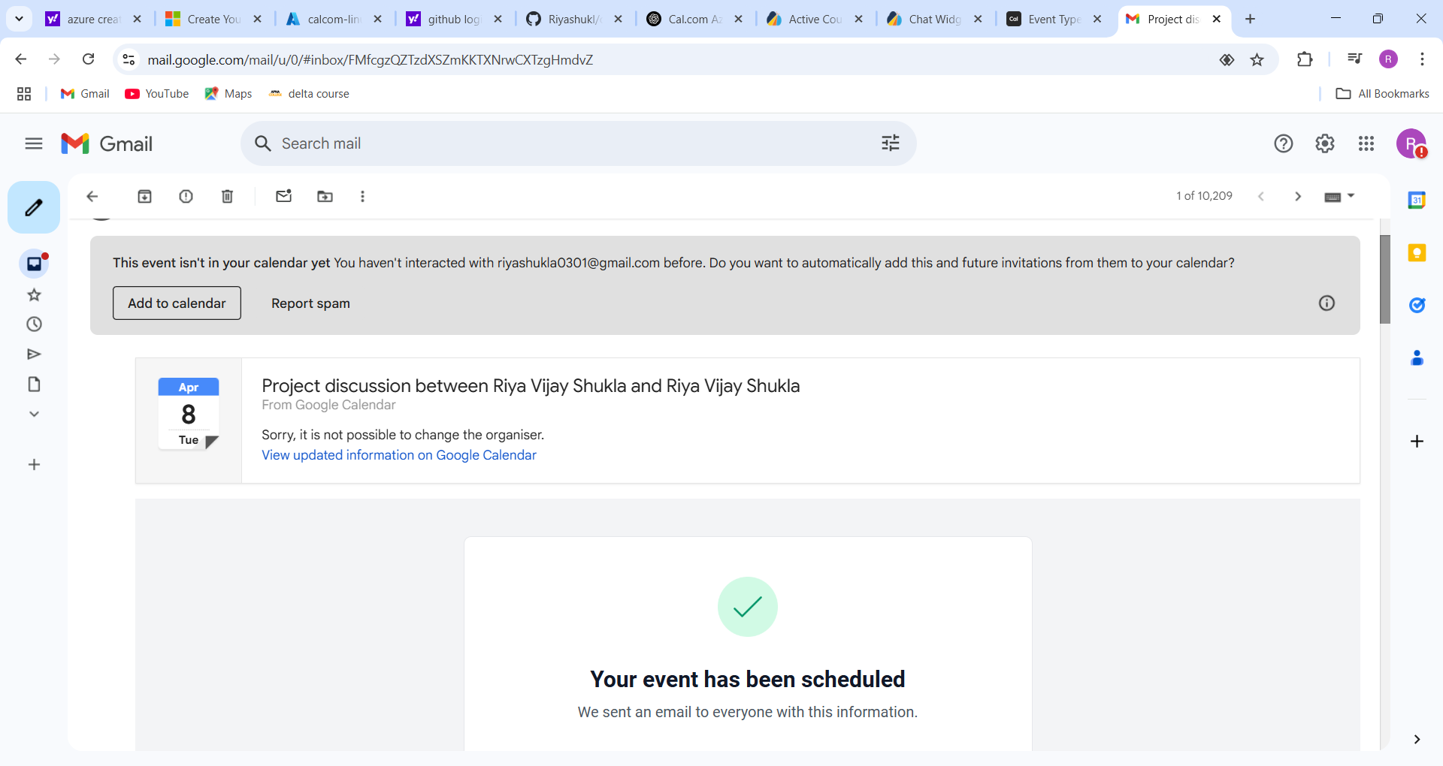

Admin can see all booking:

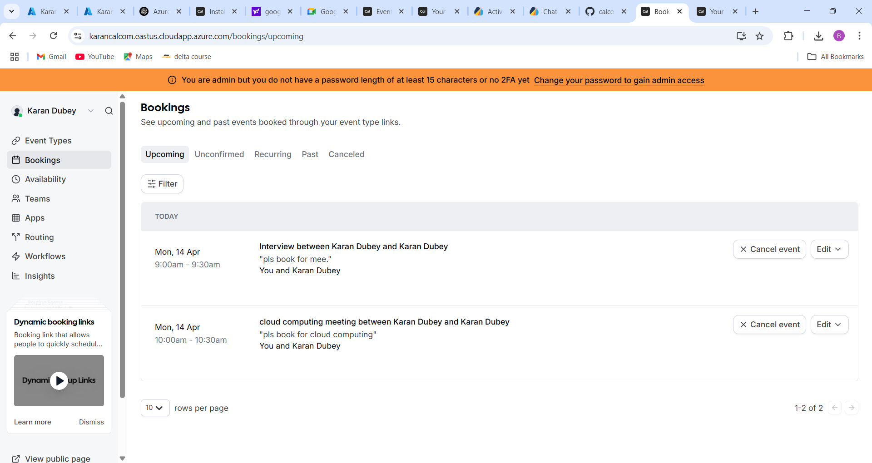

**Steps 8 :Set up Autoscaling with Azure Virtual Machine Scale Set:**

A VMSS allows you to automatically scale your app as demand changes.

**1: Go to Azure Portal**

1. Visit <https://portal.azure.com>
2. Search for **"Virtual Machine Scale Sets"**
3. Click **"Create"** > **"Virtual machine scale set"**

**2: Basics Tab**

* **Subscription:** Select your Azure subscription.
* **Resource Group:** Select existing or create new (e.g., Calcom-Project2)
* **Name:** e.g., **vmssVM**
* **Region:** Same as your main VM (e.g., East US)
* **Orchestration Mode:** Choose **Uniform**
* **Image:** Use Ubuntu Server 22.04 LTS (or your preferred OS)
* **Authentication Type:** SSH Public Key or Password
* **Username:** e.g., karandubey
* **Key:** Paste your SSH public key (~/.ssh/id_rsa.pub)

**3: Disks**

* OS disk type: Standard SSD (or Premium SSD if needed)
* No additional data disks unless required.

**4: Networking**

* **Virtual Network:** Select existing or create a new one.
* **Subnet:** Use default or create.
* **Public IP:** Create new (optional – only needed for inbound access)
* **Load Balancer:** Auto-create or use existing.

🔸 Tip: Azure will auto-provision a **load balancer** and assign the VM instances behind it.

**5: Scaling**

* **Initial instance count:** Start with 2 or 1 (up to you)
* **Scaling policy:** Manual or Auto (set rules later)
* Enable auto-scaling:
  + **CPU Threshold**: e.g., add instance if CPU > 70%
  + **Instance Limits**: min 1, max 5

**6: Monitoring**

* Enable **Azure Monitor**, **Alerts**, and **Diagnostics Settings**.
* You can create alert rules like:
  + CPU > 80% for 5 mins → trigger scale-out
  + CPU < 20% for 10 mins → scale-in

**7: Review + Create**

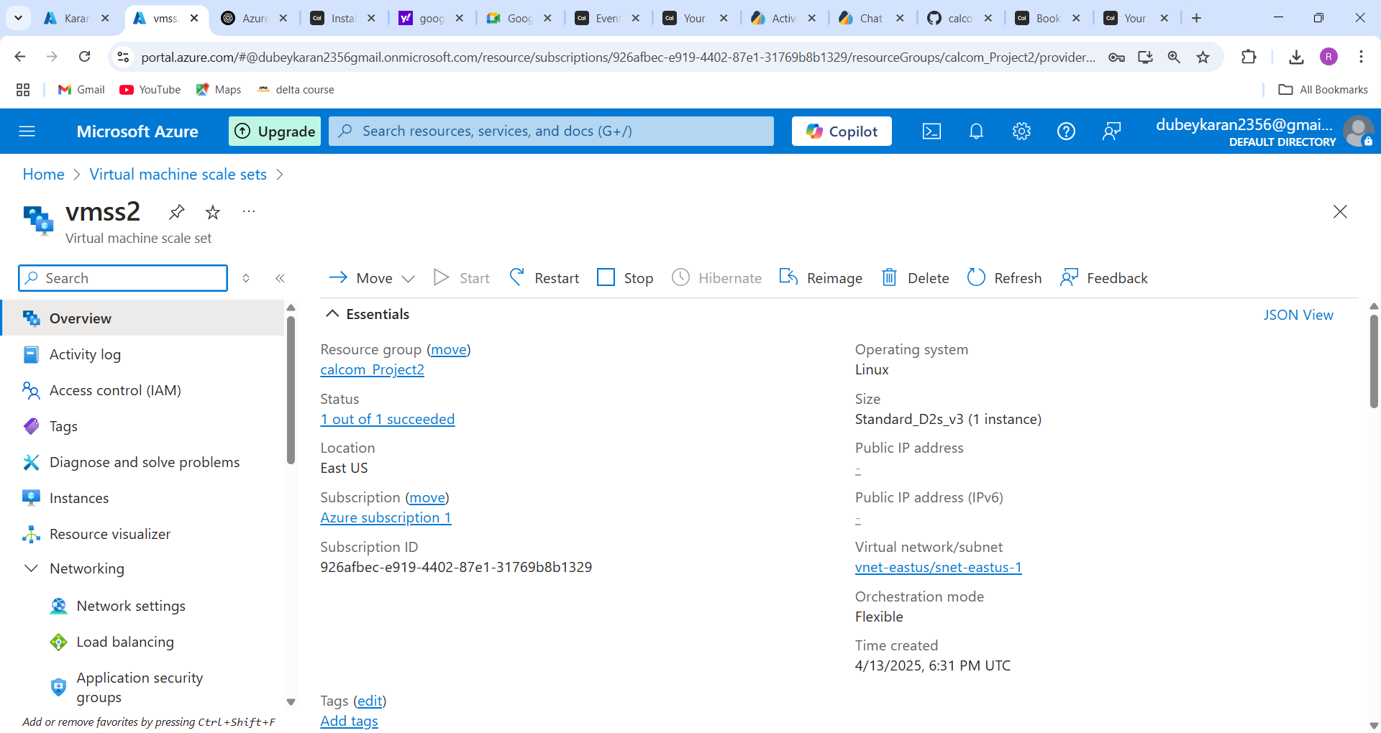

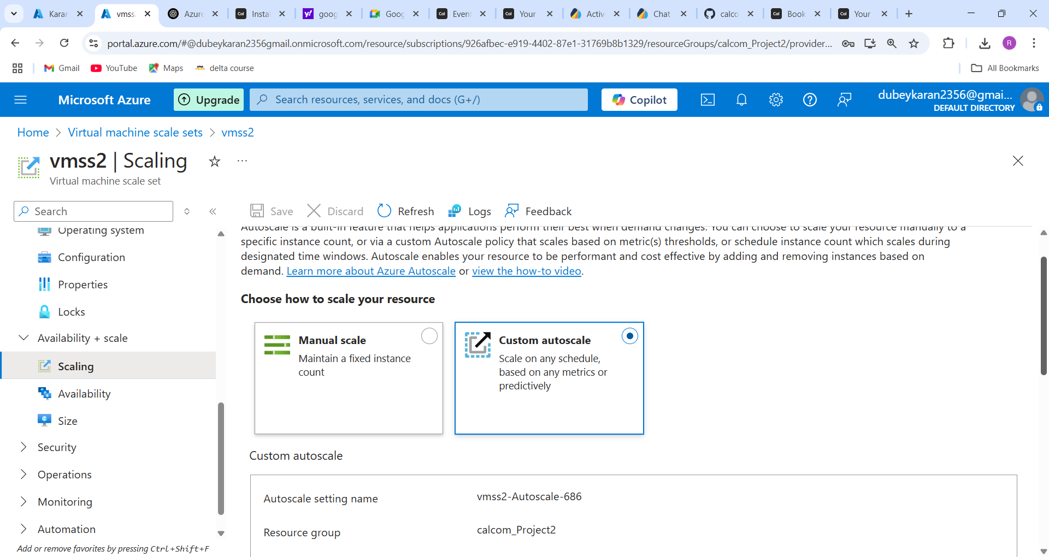

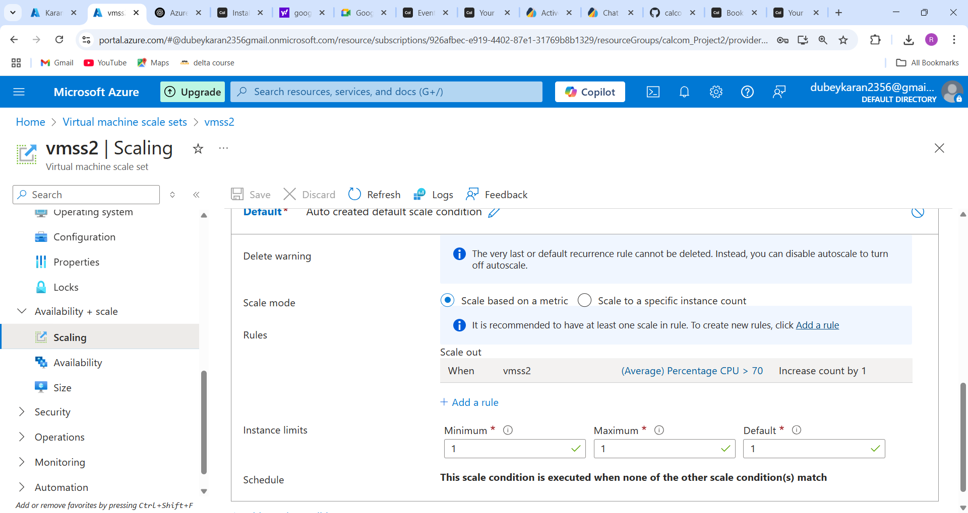

**Steps 9: Creating Alerts for failure.**

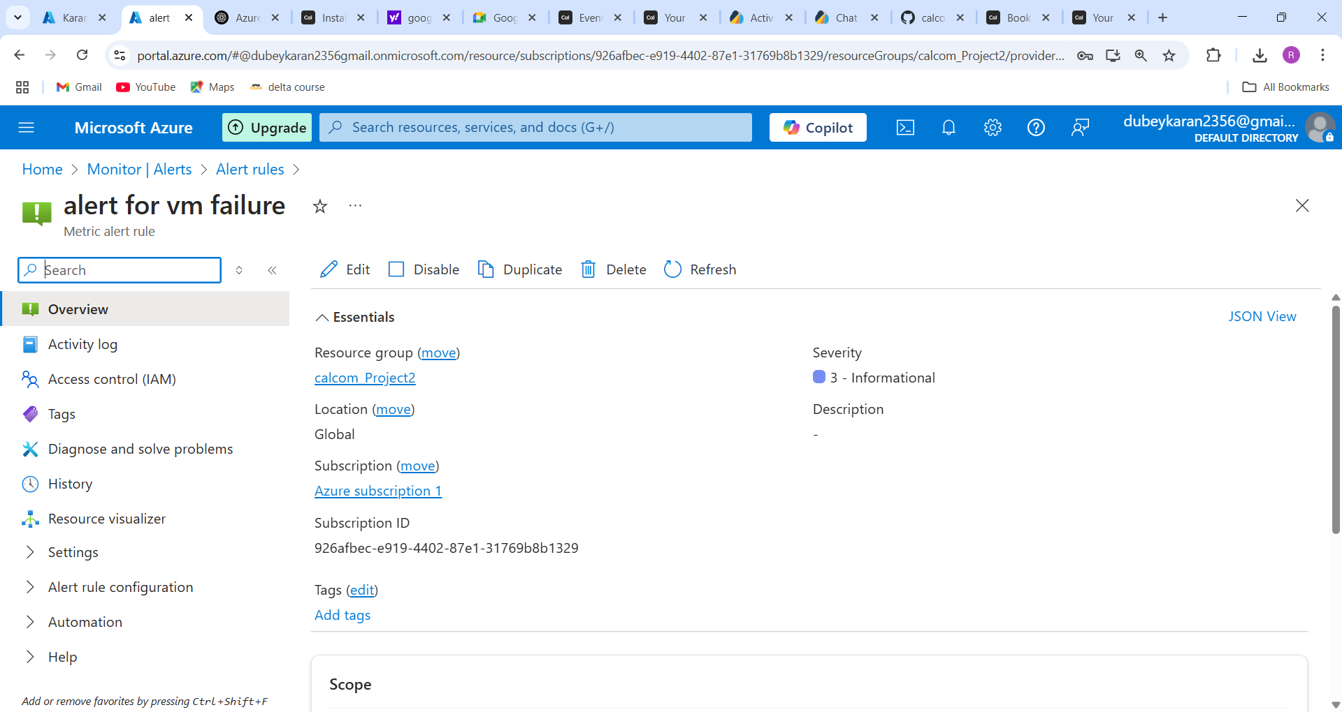

**Steps 10: Monitoring**

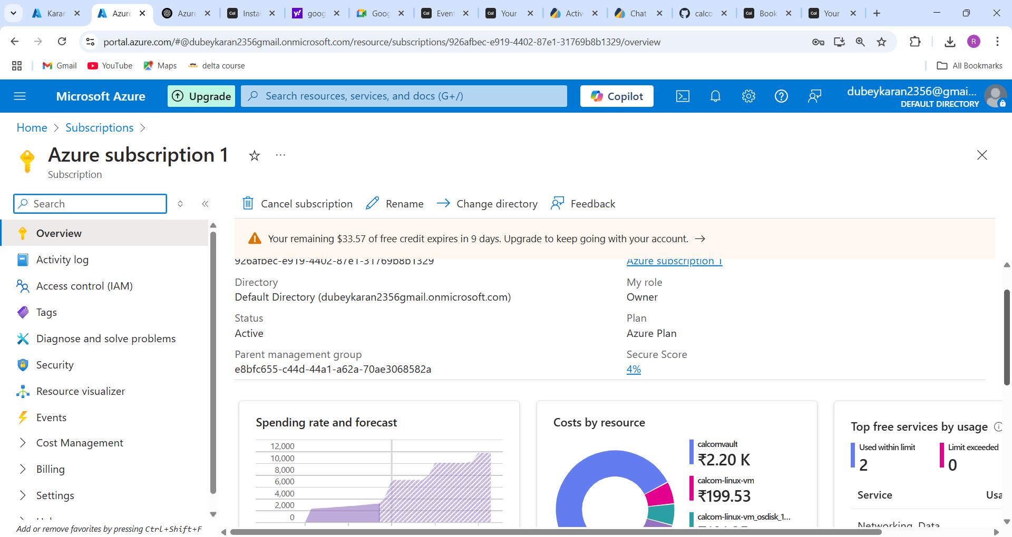

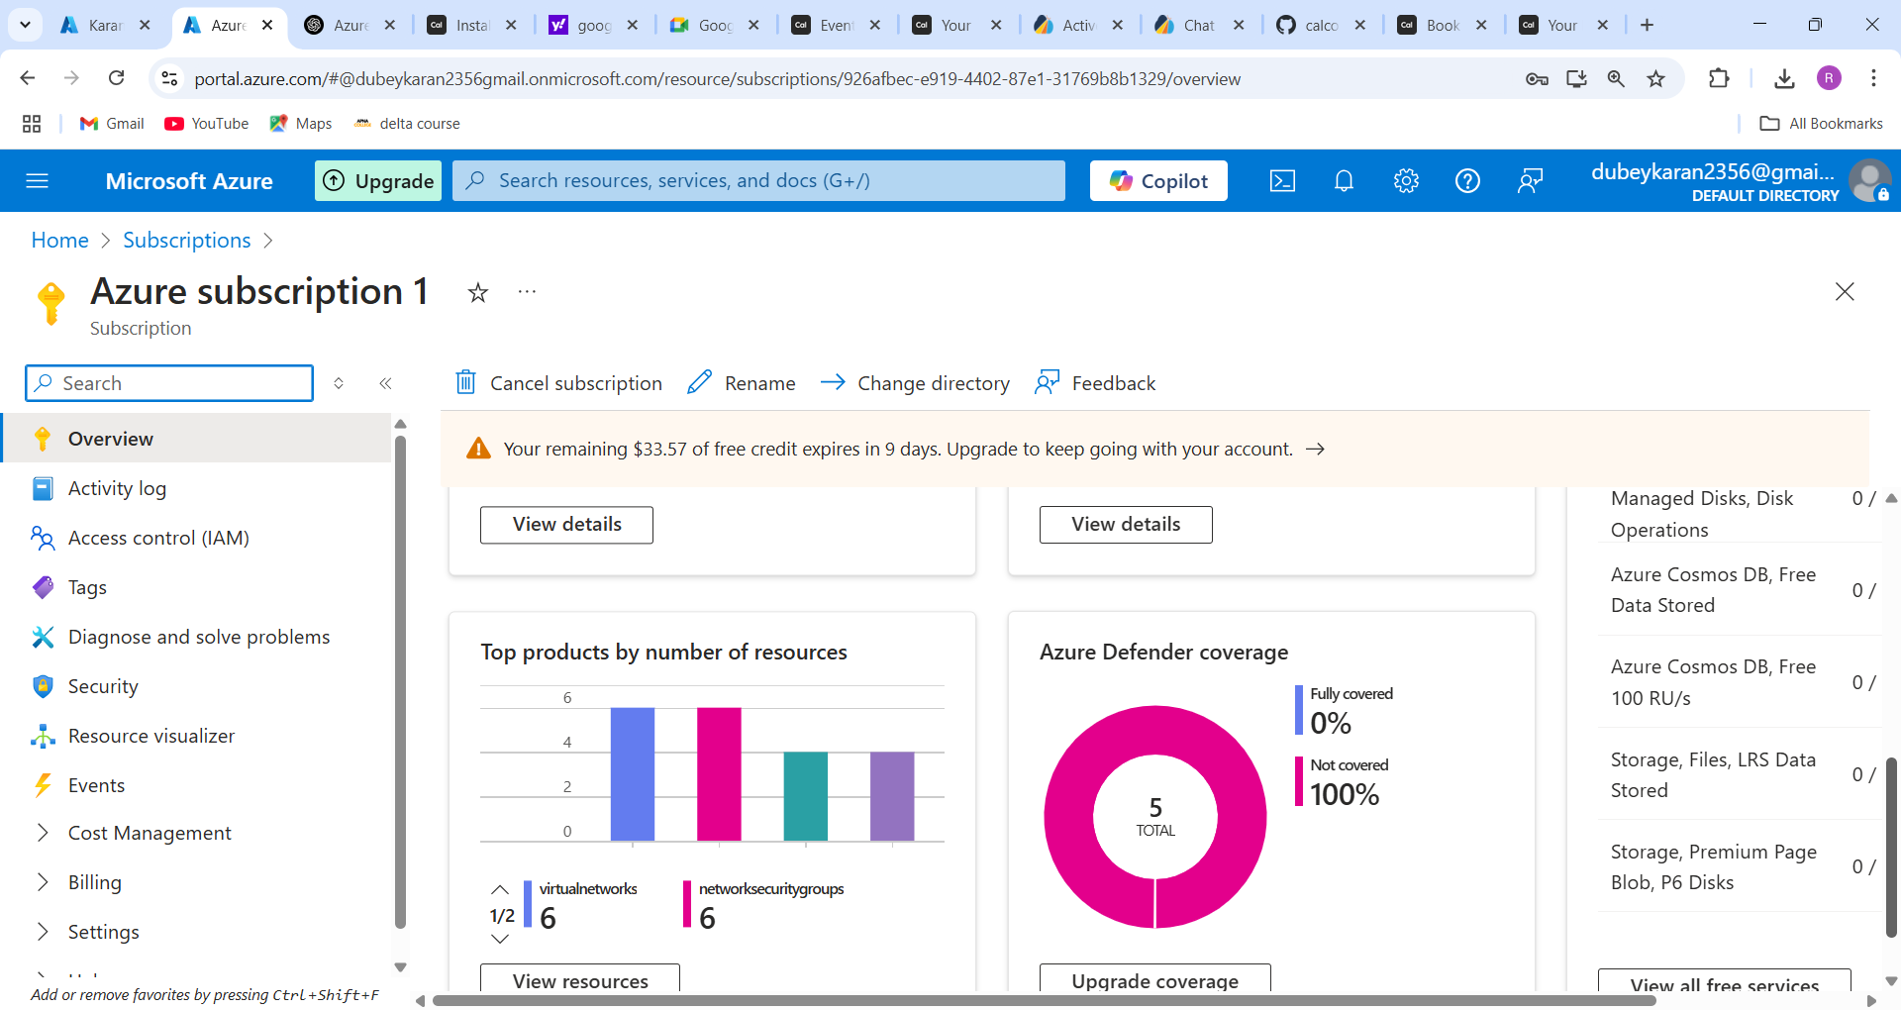

**Cost Alerts:**

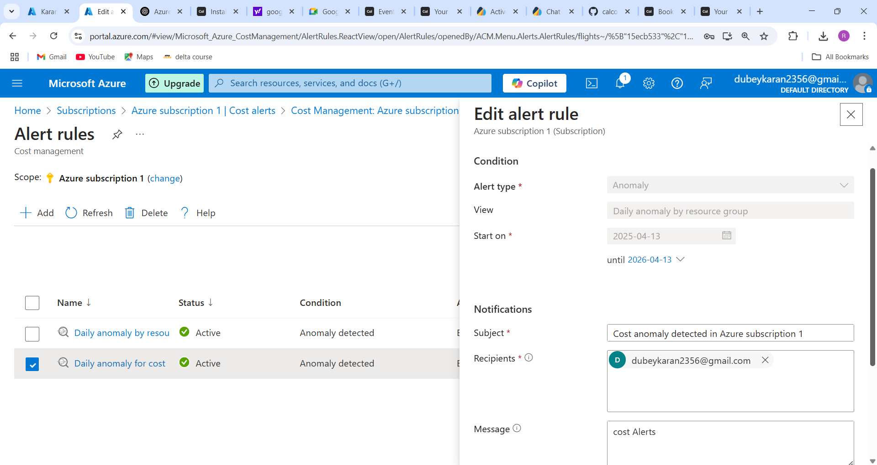

**Logs:**

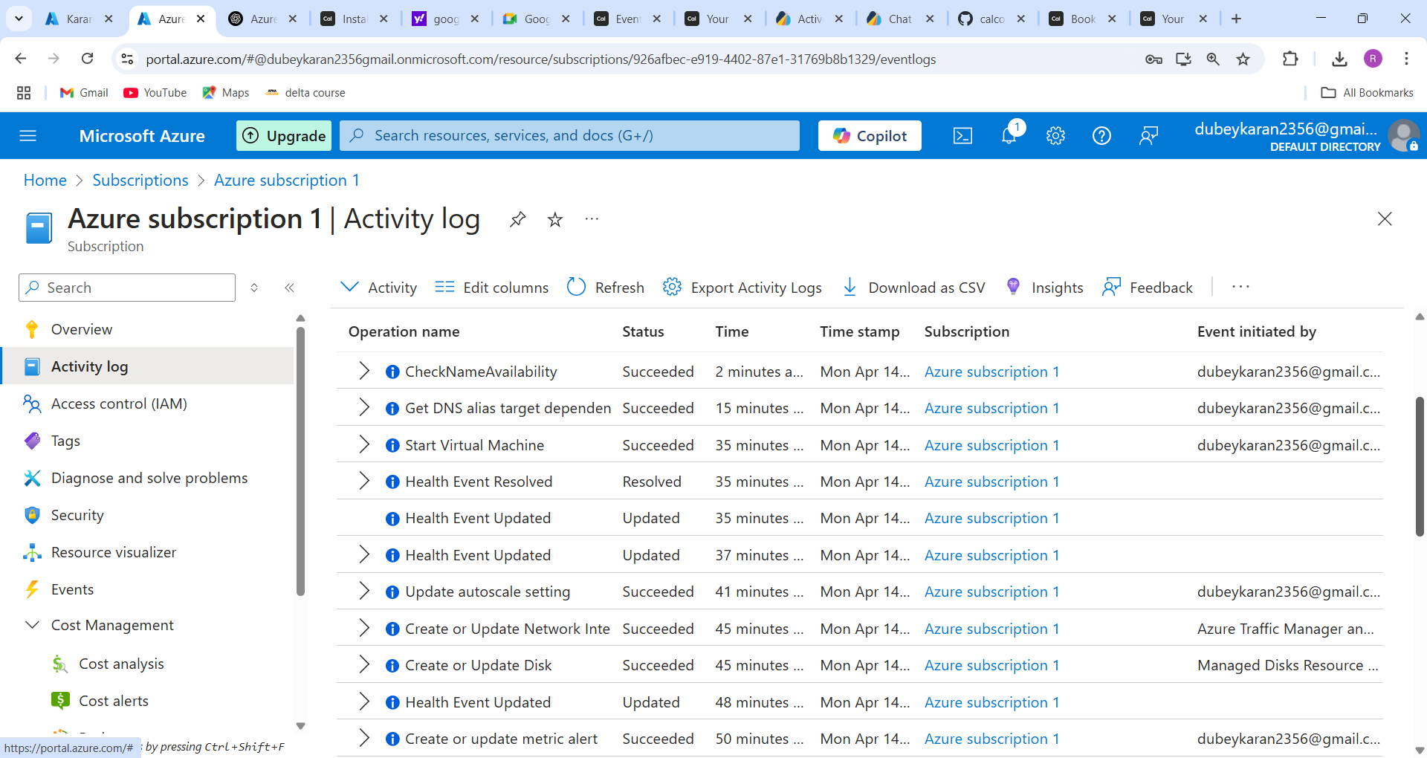

**Step 11: Push Project to GitHub**

**1. Initialize a Git repo** (if not done already)

git init

git remote add origin https://github.com/dubeykaran/calcom-azure-project.git

**2. Add all project files**

git add .

git commit -m "Initial commit with Cal.com setup"

**3. Push to GitHub**

git push -u origin main

If prompted for username/password, use your **GitHub username** and a **personal access token** (not your password). [Generate a GitHub token here](https://github.com/settings/tokens)

**✅ Step 12: Create ZIP File for Submission**

**1. Zip your project folder**

From inside the parent directory:

zip -r calcom-azure-project.zip calcom-azure-project

Make sure it includes .env, docker-compose.yaml, Caddyfile, and README.md

**2. Move ZIP file for SCP/Download**

mv calcom-azure-project.zip /home/azureuser/

chown azureuser:azureuser /home/azureuser/calcom-azure-project.zip

**3. Download ZIP using SCP**

On your local machine:

scp azureuser@<vm-ip>:/home/azureuser/calcom-azure-project.zip .

Replace <vm-ip> with your VM’s IP address.

**✅ Step 13: Record and Submit Demo Video**

**1. Record a demo showing:**

* VM and code setup
* Docker Compose up
* Accessing app in browser via HTTPS
* Your GitHub repo and ZIP file
* Azure DNS zone

**2. Tools you can use:**

* OBS Studio (for screen recording)
* Zoom (record a session)
* Xbox Game Bar (on Windows)

**3. Upload and Share**

* Upload to YouTube / OneDrive / Google Drive
* Add the video link below 👇

**📽️ Demo Video Link:**

[Insert your video URL here]